GROUP NAME - CONTROL

TERESIA MUGURE KAMAU B135/29982/2024
SAMLENSON GATHUNGU WAHU B135/28492/2024
PENINAH WAMBUI MBUGUA B135/30864/2024
ELVIS KIBE MUCHENDU B135/29865/2024
February 16, 2026
LOCAL cLINIC APPOINTMENT AND QUEUE MANAGEMENT SYSTEM

CLINIC APPOINTMENT AND QUEUE MANAGEMENT

INTRODUCTION

CHAPTER ONE: INTRODUCTION
- Background of the Study
Many clinics today still struggle with managing patient appointments and queues effectively. In most cases, patients are required to walk in, wait in long lines, or book appointments through phone calls and paper records. These methods are often slow, confusing, and easily affected by errors such as lost records, double bookings, or missed appointments. As a result, patients spend a lot of time waiting, and clinic staff are placed under unnecessary pressure trying to organize patient flow.
Long waiting times and overcrowded waiting areas are common problems in busy clinics. Patients are usually unsure of when they will be attended to or how many people are ahead of them in the queue. This uncertainty often leads to frustration, complaints, and sometimes patients leaving without receiving medical care. For healthcare workers, managing appointments manually makes it difficult to keep track of schedules, handle cancellations, and ensure that doctors’ time is used efficiently.
With the growth of technology, there is a better way to manage these challenges. A Clinic Appointment and Queue Management System can help clinics organize patient visits more efficiently. Through this system, patients can book appointments in advance, receive reminders, and monitor their position in the queue. This reduces unnecessary waiting and helps patients plan their time better.
For clinic staff and healthcare providers, the system simplifies appointment scheduling, improves record keeping, and ensures smoother patient flow throughout the day. It reduces paperwork, minimizes errors, and allows staff to focus more on patient care rather than administrative tasks.
This project aims to develop a Clinic Appointment and Queue Management System that improves the overall clinic experience. By reducing waiting times, improving organization, and increasing transparency, the system will benefit both patients and healthcare providers, leading to better service delivery and improved patient satisfaction.
- Statement of the Problem
Wastage of time, this is because most clinics uses manual way of booking appointments like phone calls, paper records. They are therefore supposed to queue in long lines leading too much wastage of time. It also delays one department can slow down the entire service process, leading to fewer patients being treated hence now others supposed to be back next day.
Due to overcrowding there can also lead to the spread of diseases that some patients can be having which are contagious. This overcrowding can lead to exhaustion of health workers, which increases the chances of mistakes, reducing efficiency, and lowers the quality of care given to patients. Staffs may also find it difficult to monitor patients properly when the number of patients exceeds available resources.
Clinic staff also face difficulties when managing appointments manually. Keeping track of patient schedules, handling cancellations, and coordinating doctor’s availability can be stressful and leads to error such as double booking or lost of records. This increases the administrative workload and reduces the time staff can spend on actual patient care.

- Justification
This project is justified by the need to improve efficiency and service delivery in clinics and hospitals. Many healthcare facilities still experience long waiting times, overcrowding, poor appointment scheduling, and wastage of time due to manual systems. These challenges negatively affect patient satisfaction and place unnecessary pressure on healthcare workers.
By introducing a Clinic Appointment and Queue Management System, clinics can better organize patient visits, reduce congestion in waiting areas, and ensure that patients are attended to in an orderly and timely manner. Patients will be able to book appointments in advance, receive reminders, and know their position in the queue, which helps them plan their time more effectively.
The system also benefits healthcare providers by reducing paperwork, minimizing scheduling errors, and improving record management. This allows doctors and clinic staff to focus more on patient care rather than administrative tasks. In addition, better patient flow helps prevent overcrowding, reduces stress on staff, and lowers the risk of infection spread within the clinic.
Overall, this project is justified because it promotes efficient use of time and resources, improves the quality of healthcare services, and creates a better experience for both patients and healthcare providers.

- Objectives

General Objective
- Design system
- Develop prototype
- Evaluate system

Specific objective
- Identify and analyze user requirements.
- Develop a login and registration module.
- Test the system for functionality and performance.
- Evaluate system usability and user satisfaction.

CHAPTER TWO: LITERATURE REVIEw
Health facilities faced major challenges like long waiting times, poor appointments scheduling, overcrowding, manual record errors. Traditional paper-based systems are slow and inefficient. Researchers and developers have proposed computeralised systems to improve clinic operations.
Many studies showed that digital appointment systems help reduce patient waiting time, improve doctor time management, avoid double booking. For example, hospital management systems implemented in facilities such as Kenyatta National Hospital use electronic booking to improve service delivery. Online scheduling allows patients to book remotely, automated reminders, better daily planning.
Queue management systems are used to organize patient flow, provide queue numbers, display real-time services updates. Modern hospitals such as Aga Khan University use digital queue displays to reduce congestion and confusion. Research showed queue systems improve, reduce patient frustration, increase staff efficiency.
Recent studies recommended combining appointment booking, queue tracking, patient records. Integrated system helped clinics predict busy hours, allocated doctors efficiently, monitor service time. Technologies used are web –based systems, mobile application, cloud databases.
Despite improvements, some clinics still faces poor internet connectivity, lack of technical skills, high system implementation costs, data security concerns. Many small private clinics in developing countries still use manual registers.
From the reviewed literature, digital appointment and queue management systems reduce waiting time, improve operational efficiency, enhances patient satisfaction, support better healthcare delivery. Therefore , developing a simple, secure, and affordable system for clinics is necessary.

CHAPTER THREE: MATERIALS AND METHODS

Proposed work
The system was developed using the waterfall model, which incuded;
- Requirement analysis
- Identified problems in the current manual system
- Collected requirements from clinic staff
- Defined system objectives

- System design
- Designed use case diagrams
- Designed class diagrams
- Designed database structure
- Created system architecture

- Implementation
- Developed frontend (user interface)
- Developed backend logic
- Connected system to database

- Testing
- Unit testing of modules
- Integration testing
- User acceptance testing

- Deployment
- Installed system in clinic
- Trained users
- Began system operation

- Maintenance
- Fixed errors
- Updated system features
- Performed regular backups
The proposed work include the following;

Requirement analysis and specification
- Software equipment
- Frontend tools used
- HTML
- CSS
- JAVASCRIPT
- VISUAL STUDIO CODE
- CHROME
- Backend tools used
- Development tools_ Visual studio code
- Database tool_ MYSQL database
- Web server
- Testing tools_ chrome
- Documentation tools_ Microsoft word

- Hardware requirement
- Computer_ Used for creating the system
- Printer_ Used for printing documents
- Network_ Used for internet connection

Conceptual framework/Experiment/System design
Design of forms. (Diagrammatic outlook of project work)

USE CASE DIAGRAM AND CLASS DIAGRAM RESPECTIVELY
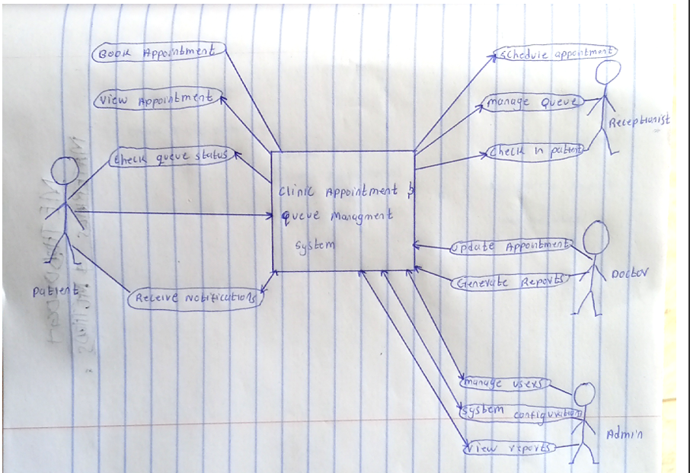
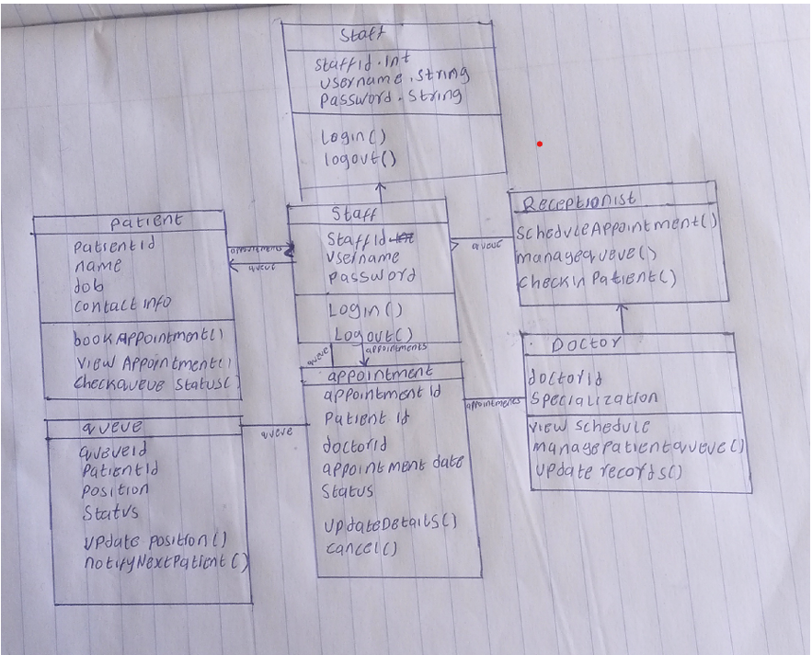

Functional requirements
- The system shall allow patients to register and log in.
- The system shall allow patients to book appointments.
- The system shall allow staff to view and manage appointments.
- The system shall allow doctors to update consultation status.
- The system shall store patient records in a database.

Experimental and data collection procedures
We used the following procedures to collect data:
- Observation- We went to Embu level (iv), we observed how they were dealing with queues, and also appointment, also we visited University of Embu clinic and observed how they are working.
- Interview- firstly, we interviewed each other about our experience when we went clinics. Then we interviewed staffs that are working at the hospital.

REFERENCE

Citing a journal article in print
Smith, J. A. (2018). Development of a clinic appointment and queue management system.
International Journal of Healthcare Information Systems, 12(3), 45–53.
Citing a journal article found online
Rahman, M. T., & Lee, S. (2021). Web-based clinic appointment and queue management system
for improved patient flow. Journal of Medical Systems, 45(6), 112–125.
https://doi.org/10.1007/s10916-021-01789-3
Citing a book in print
Dennis, A., Wixom, B. H., & Roth, R. M. (2015). Systems analysis and design (6th ed.). John Wiley
& Sons, New York, USA.
Citing an e-book from an e-reader
Laudon, K. C., & Laudon, J. P. (2020). Management information systems: Managing the digital firm
(16th ed.) [Kindle version]. Retrieved from https://www.amazon.com

APPENDICES

